Exercise 4.5: Return Data from a Stored Procedure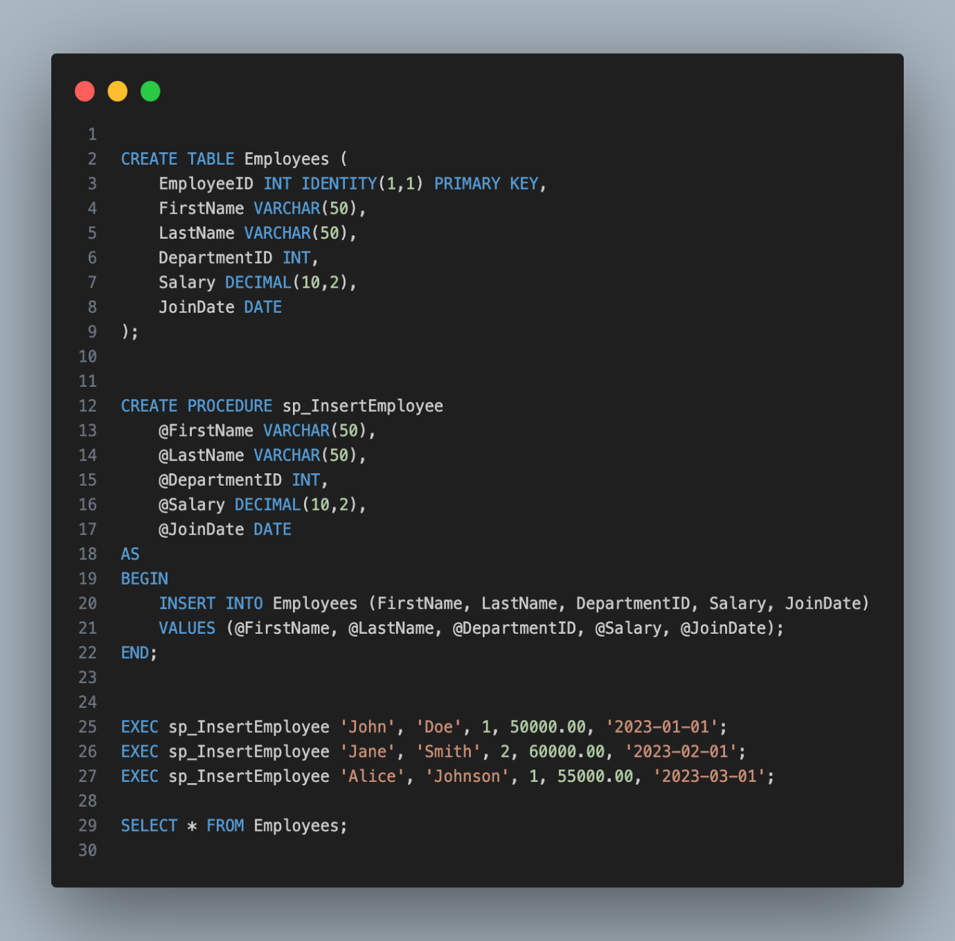

Output :

